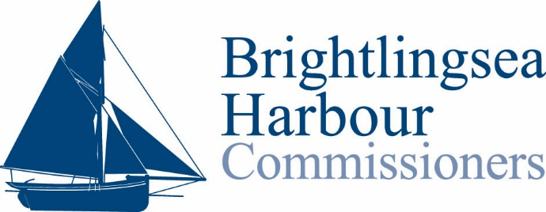

BRIGTHLINGSEA HARBOUR WIVENHOE BOAT TRIPS

**Email this ticket to reserve your seats and we will be in touch!**

BOAT TRIP DATE …………………………………………………………………….

NAME : ………………………………………………………..

ADULT ……………………………………………………….. COST……………. CHILD……………………….. COST ……………….

CONTACT DETAILS

MOBILE……………………………………………………….. Email ……………………………………………………………

Tel: 01206 303200

Email: [mail@brightlingseaharbour.org](mailto:mail@brightlingseaharbour.org)

www.brightlingseaharbour.org