LOCAL NOTICE TO MARINERS NO.

15/07/2026

SUNK VESSEL

In approximate position
51° 46.792 N, 000° 59.955 E.

A Small leisure day fishing boat that stranded on a sandbank on Saturday. The vessel is a Shetland 570 (5.7 m long) with a dayglow yellow upper hull and cuddy, and the antifouling is blue. Vessel has a paddeboard and white marker buoy attached.

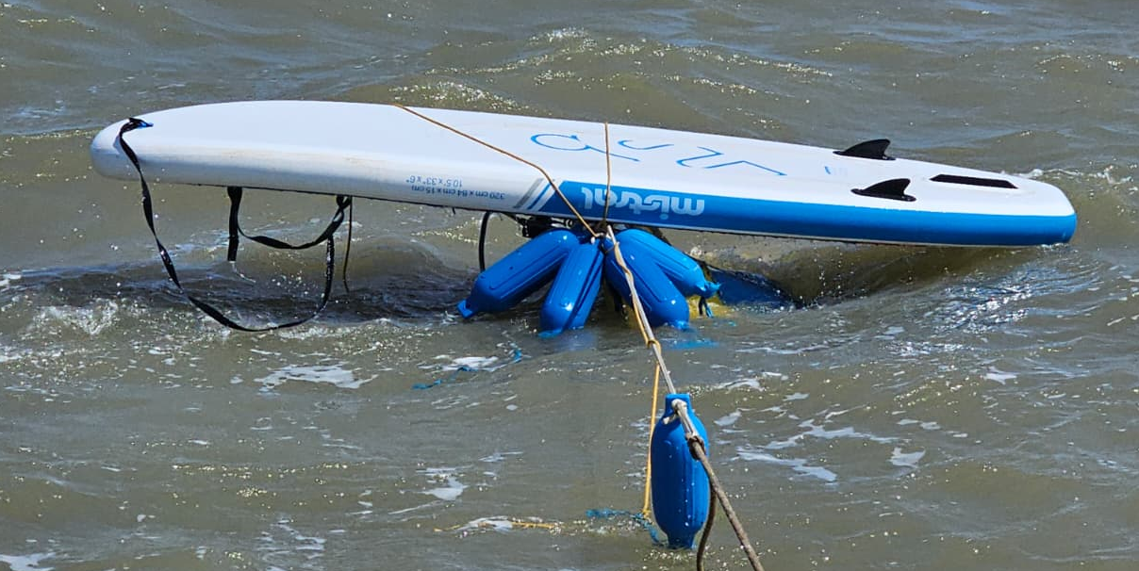
All vessels are advised to keep clear of the sunken vessel.
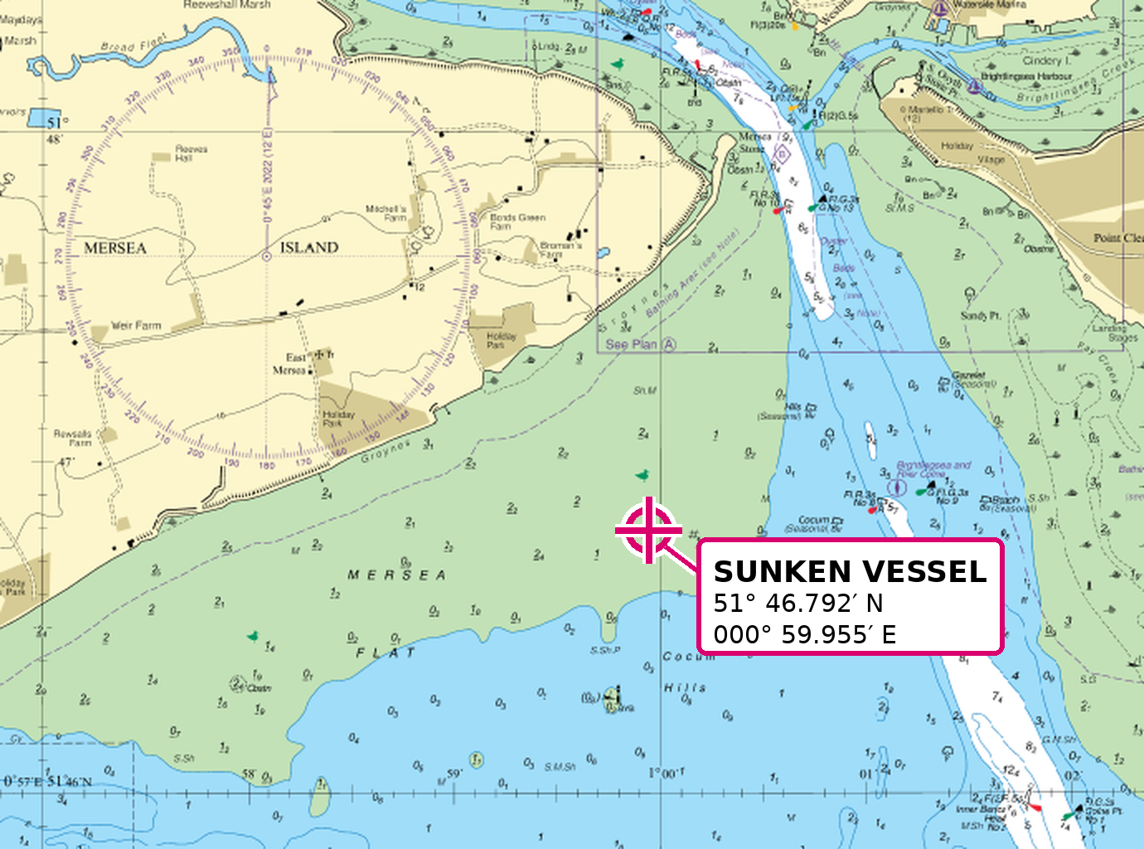
For further information contact Brightlingsea Harbour Authority on VHF channel 68.

Steven Young
Deputy Harbour Master
15/07/2026

